Packet Tracer - Investigate a Threat Landscape
Objectives

Part 1: Investigate a Network Configuration Vulnerability

Part 2: Investigate a Phishing Malware Vulnerability

Investigate a Wireless Network and DNS Vulnerability

Background / Scenario

The threat landscape consists of all the vulnerabilities that can be exploited by threat actors. Every cybersecurity incident involves the exploitation of vulnerabilities by different types of threat actors. Some threat actors want money, others want to be famous, and yet others want to destroy information and infrastructure.

In this activity, you will investigate three vulnerabilities that can be exploited by threat actors.

Note: In this activity, both the Data Center and ISP/Telco sites are locked.
Instructions
Part 1: Investigate a Network Configuration Vulnerability

Sometimes network security vulnerabilities can happen by accident. For example, forgetting to update server or host software may expose known vulnerabilities that could easily be mitigated with a simple update. Similarly, vulnerabilities may be introduced when a network device is not configured properly, or a device is defective. In this part, you will explore a vulnerability that results from a device that is not properly configured with security best practices.
Step 1: Use a guest network to gain access to other devices on the network.

In Greenville, locate Smartphone 3 just outside of the Home location.

Mary is the owner of this smartphone. She is a friend of Bob who lives in the house.Mary is studying to eventually get a job in cybersecurity defense and is familiar with network penetration testing. She noticed that a guest wireless network is open and accessible by anyone. She connected to the guest network and used Nmap to run a scan, which can identify and discover details about all the active devices. One of the devices appears to be a webcam. Its IP address is 192.168.100.101.
Click Smartphone 3, and then click Command Prompt. Enter the command ping 192.168.100.101. After one or two #Request timed out# messages, the remaining pings should be successful.

Mary informs Bob that the network is very vulnerable to attack. Someone could take control of the webcam, for example, and watch video from inside the house. Bob invites Mary to come in, investigate the issue, and propose a solution.

Part 1: Investigate a Network Configuration Vulnerability
1)Determine the ip addrees of the pc at the room
We will try to understand why we can connect to the guest WiFi without typing a password. Also, we will analyze potential vulnerabilities at home.
We typed ipconfig.
The result is:

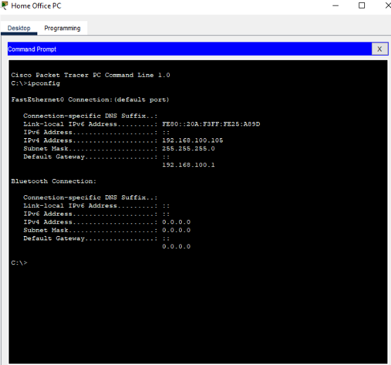

To connect to the gateway using a browser, we opened the browser and entered the IP address of the gateway.
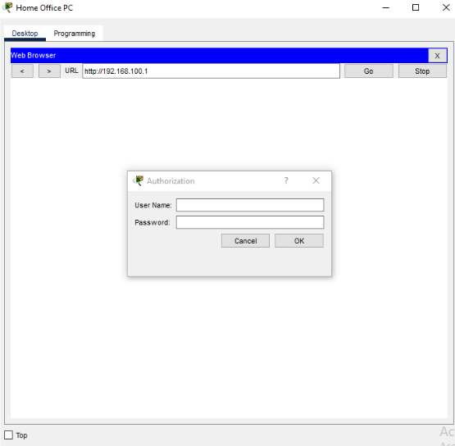
Documentation:
We have to enter the username and password that are required.
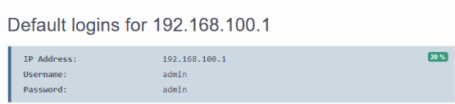
This table appears:
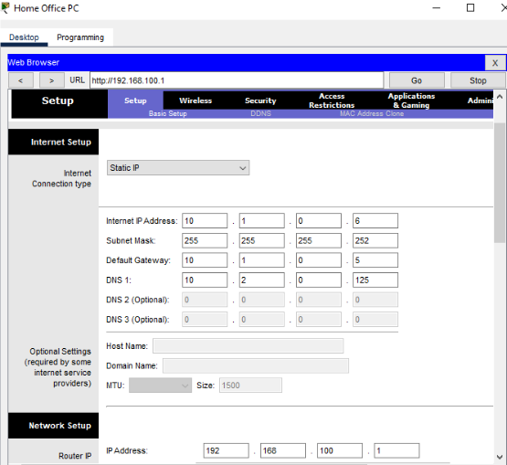
When we clicked on the "Wireless" option, we wouldl discovered that there are three active radios..

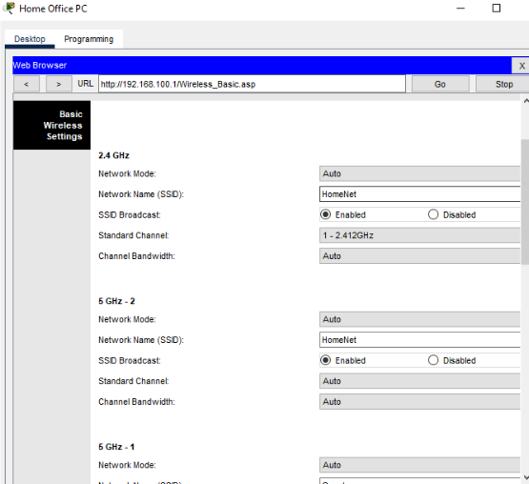
After that,we clicked on wireless security to discover the protocols implemented.

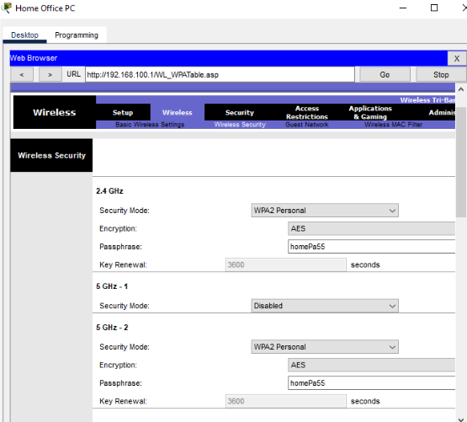
We remarked that security is activated for only two devices
=>It's not activated for the guest wifi that we connected into it in the beginner.
We were able to access to network without logging in.
We wanted to investigate more so we clicked on Guest Network ,we found that it has no security mode activated and it allows guests to see each other and to access the local network.
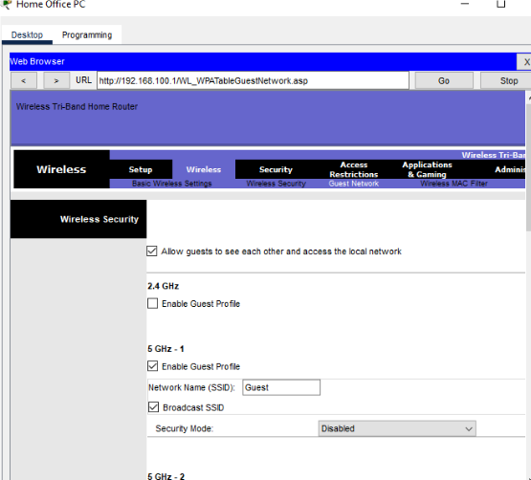

Part 2: Investigate a Phishing Malware VulnerabilityWe will simulate and send phishing emails:

Phishing is a type of social engineering attack where a threat actor disguises themself as being a legitimate, trusted source in order to trick you into installing malware on your device, or share personal or financial information. Phishing attacks typically come through emails or phone calls. Unlike other network vulnerabilities, the primary vulnerability in phishing attacks is the users of the network. For this reason, an important defense against phishing is training users on how to prevent phishing exploits.

In this part, you will simulate and investigate a phishing attack.

Note: This activity is for demonstration purposes only. Writing and sending phishing email messages is unethical and is considered a criminal attack in most jurisdictions.
Step 1: Pose as a threat actor and create a phishing email.

Navigate to the Cafe network
Click the Cafe Hacker Laptop > Desktop tab > Email.
Click Compose.

Use your imagination to write a phishing email. Your objective is to persuade the user to copy and paste a URL from your email message into their browser. Include the link pix.example.com in the email. You can look for example phishing emails online to see how threat actors write this type of email.

Note: Links in phishing emails are typically active or #hot# links. All the victim has to do is click it. However, Packet Tracer does not support the use of active links inside the email client.
Send your email to three people inside the Branch Office network. Their email addresses are as follows:

user1@mail.isp.net
user2@mail.isp.net
user3@mail.isp.net

Step 2: Open the emails received from the threat actor.

Navigate to the Branch Office.
Click one of the devices, either PC-BR1, Laptop BR-1, or Laptop BR-2.
Click Desktop tab > Email, and then click Receive. You should receive the email that you just sent.

Note: Packet Tracer may take up to a minute to converge. You may need to click Receive several times if the email is not successfully retrieved.
Optional: Go to the other victim devices, open their Email client, and click Receive to verify that they also received your phishing email.

Step 3: Pose as a victim and follow the phishing instructions.

Read the email and copy the website address.
Close the Mail Browser window, and then click Web Browser.
Paste the URL into the URL field, and then Go.

Note: Packet Tracer may take up to a minute to converge. You can click Fast Forward Time (Alt+D) to speed up the process.

Step 2: Explore the Home network to identify the vulnerability.

Click Home. Knowing that home routers typically control home wireless networks, Mary heads straight for the home office and sits behind the desk. She will use the Home Office PC to connect to the router. But first she needs to determine the IP address.
Click Home Office PC > Desktop tab > Command Prompt, and then enter the command ipconfig.

The default gateway is the IP address for the Home Wireless Router.

We navigated on the cafe network and created "an official email"
Our goal is to persuade the receiver to copy the url sent on their browser.

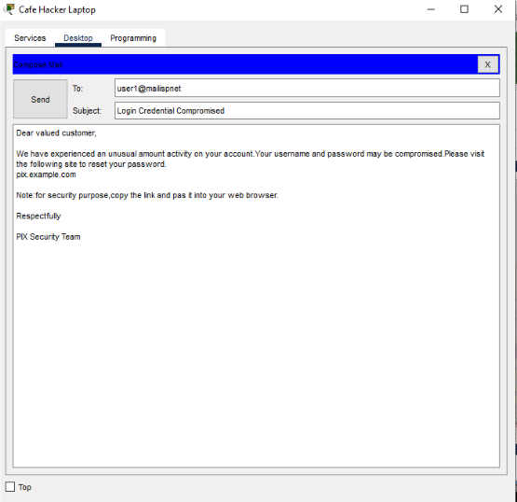

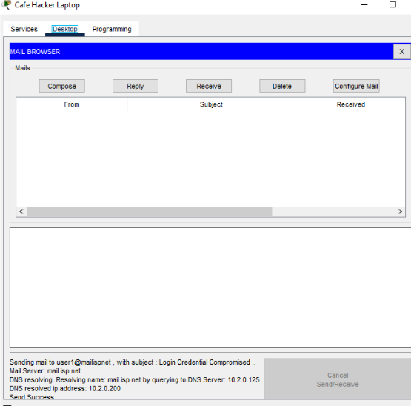

We sent the same email to three users.
We checked if we had received the emails on the branch office desktop

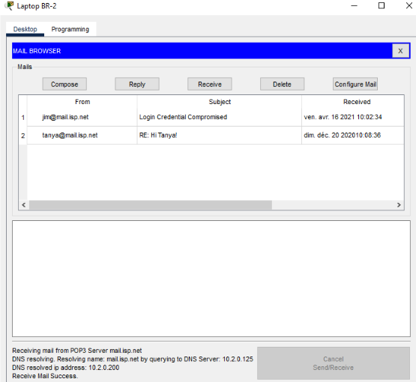

We considered that the receiver did the instructions mentiened in the email.
When we typed the url on the browser,we received this message:
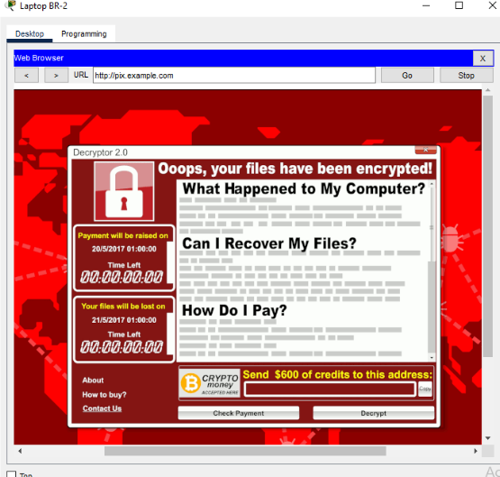
=>It's a ransomware attack:when we clicked on the website,our files would be encrypted.The attacker demandes money to recover the files.
What is worse this email will be sent to all your contacts on the same network.

If the email virus spreads this message to everyone in the network, those users also follow the instructions, then numerous hard drives could be encrypted and a lot of data potentially lost. In some cases, companies and other organizations have paid thousands of dollars in hopes of recovering the encrypted data.
Employees should be trained how to identify phishing emails and the actions that should be taken to prevent damage from them. In addition, organizations can configure firewalls, intrusion prevention systems, and other security devices and software, to block phishing emails before entering the network. Some businesses subscribe to services that compile and maintain lists of malicious websites. The security devices in the organization can then uses these lists to automatically update filters for blocking malicious traffic.

Part 3: Investigate a Wireless Network and DNS Vulnerability

Your average network user tends to trust open Wi-Fi networks out in public places. Using Wi-Fi instead cellular data services can provide faster data rates and be more cost effective. However, threat actors can configure a laptop with a Wi-Fi interface that can act as both a Wi-Fi access point and a Wi-Fi client. This means that threat actors can create their own wireless networks and broadcast a convincing SSID to potential victims in public places. Threat actors use these rogue access points to create main-in-the-middle attacks. In this attack, threat actors can capture and read all the wireless traffic from devices that associate with the rogue access point, potentially learning usernames, passwords, and other confidential information.

In this part, you will investigate how a rogue access point can be used to entice users to connect to a fake wireless network. When combined with network services such as DHCP and DNS, users can become victims of malicious website attacks through DNS hijacking.
Step 1: Connect to the threat actor’s wireless network.

Navigate to the Cafe. Notice the threat actor sitting in the corner.
Click the Hacker Backpack and investigate the contents. In his backpack, he has a wireless router and a network sniffer. His goal is to intercept user traffic and direct it to a malicious server.
Return to the Cafe and click the Cafe Customer laptop > Desktop tab > PC Wireless application.
Click the Connect tab. You may need to click Refresh to see the list of available wireless networks.

Part 3: Investigate a Wireless Network and DNS Vulnerability
At the cafe we tried to connect to the wifi,the hacker is also there,he had a router and a hacker snifer to intercept the network.
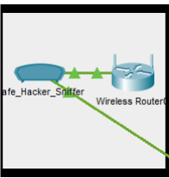
We tried to connect to wifi through attacker's pc and acessed to www.friends.example.com.
=>There is no problrm.
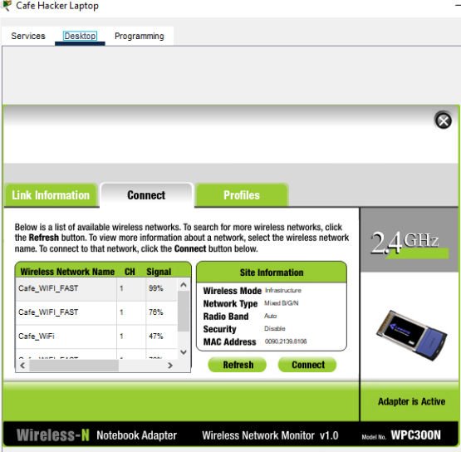
We tried to do the same steps from a customer's pc .The customer tried to access to a "legitimate" website www.friends.example.com but this message have appeared:

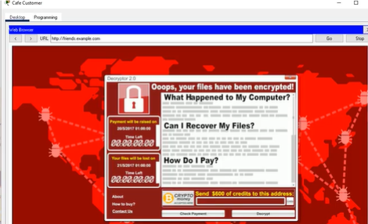
We tried to investigate the source of the attack.

If we compare the subnetting address of customer's laptop ip address and vpn's laptop ip address ,we will remark that they are not on the same network and the dns server addresses are different
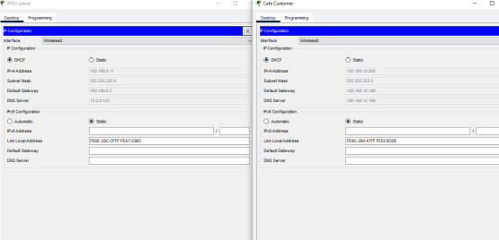
And we remark that the DNS server of the cafe customer is the IP address of the hacker
on hacker's laptop,we remark that there is the same ip address for :
friends.example.com and mail.isp.net(the phishing email)
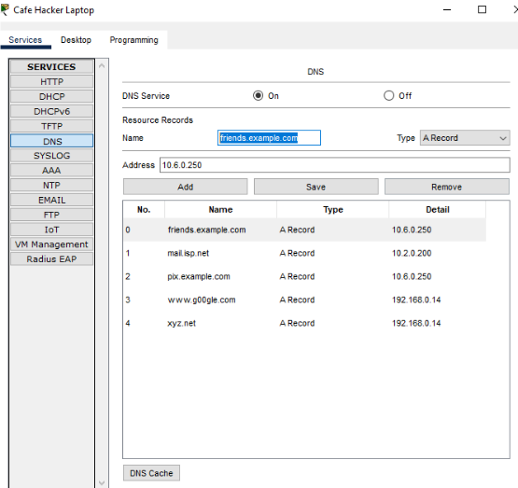

=>When the customerr connects to the rogue access point (The wifi provided by the hacker),the dhcp server of the hacker distributed the hackker's ip address as a dns server for the cafe .This dns server has a malicious address but it disguises under the name of a legitimate website friends.example.com.When the customer tried to visit this website traffic was redirected to a malicious website=>Ransomware was installed and customer's files were encrypted.

